MySQL Assignment - 3

1. write a SQL query to find Employees who have the biggest salary in their Department

##### select e.emp_id, e.emp_name, e.salary, e.dept_id, d.dept_name from employee e inner join department d on e.dept_id=d.dept_id,( select max(salary) mx_salary, dept_id from employee group by dept_id) k where e.salary=k.mx_salary and e.dept_id=k.dept_id order by dept_id ;

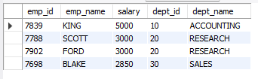

2.write a SQL query to find Departments that have less than 3 people in it

##### select d.dept_id, d.dept_name DepartmentName, case when k.total is null then '0' else k.total end 'Total Employees' from (select count(emp_id) as total, dept_id from employee e group by dept_id) k right join department d on k.dept_id=d.dept_id where k.total<=3 or k.total is null;

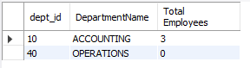

3. write a SQL query to find All Department along with the number of people there

##### select d.dept_id, d.dept_name DepartmentName, case when k.total is null then '0' else k.total end `Total Employees` from (select count(emp_id) as total, dept_id from employee e group by dept_id) k right join department d on k.dept_id=d.dept_id;

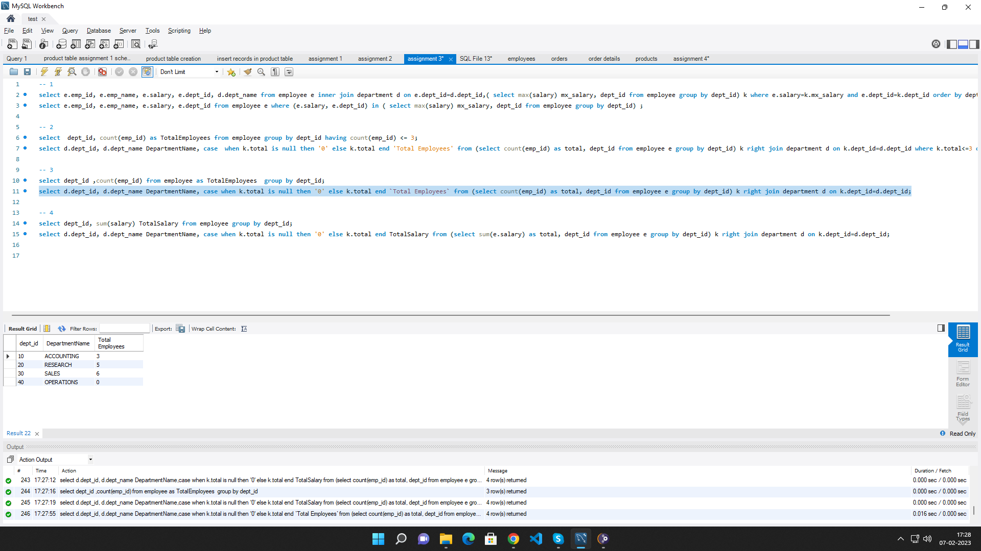

4. write a SQL query to find All Department along with the total salary there

##### select d.dept_id, d.dept_name DepartmentName, case when k.total is null then '0' else k.total end TotalSalary from (select sum(e.salary) as total, dept_id from employee e group by dept_id) k right join department d on k.dept_id=d.dept_id;



 